MSDS Project 1 Codebook

The FrankenBeer Team

* Allen Crane
* Nick Cellini
* Chris Graves
* Heber Nielsen
* Quincy Roundtree

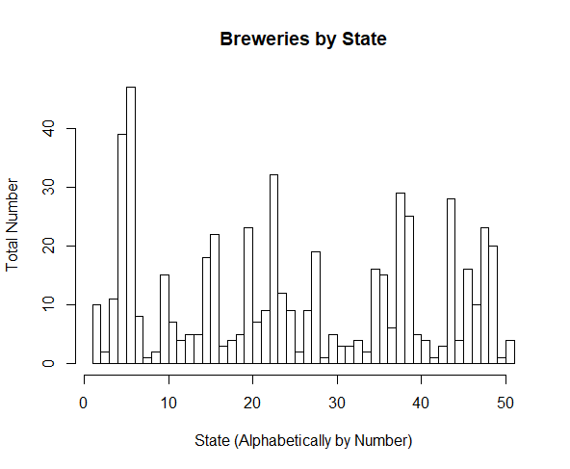

Files

Github Repository: <https://github.com/nickcellini/DDS-Case-Study-ACQN>

* **FOLDER “Original Data”**. This folder contains the following two files:
  + Beers.csv

Description: Original data file containing information on beers. File obtained from course professor, Dr. Jacquelyn Cheun. This file has the following columns of data :

* + - Column – “Name”. This column lists individual beers by the name of the specific beer.
    - Column – “Beer_ID”. This column provides an identification number specific to each beer in the “Name” column. Our research did not identify the source of the beer ID number. The number is identical to that listed in the “Brew_ID” variable in “Breweries.csv”.
    - Column - _”ABV”. This column lists the alcoholic content of the beer, as alcohol by volume (ABV). The number is the fraction of a total volume (1.00) that is alcohol. Multiplying this number by 100% gives the more common “percent alcohol”.
    - Column – “IBU”. This column lists the bitterness rating of each beer, as measured by industry standards. The rating is in “International Bitterness Units”.
    - Column – “Brewery_ID”. This is a number designating the specific brewery which brews the given beer. Our research did not identify the source of the brewery ID number.
    - Column – “Style”. A designation of the class which describes the type of beer each entry belongs to. Source is the beer industry (generally the brewer’s description of the beer).
    - Column – “Ounces”. The volume of the standard individual container for purchase of that specific beer, in fluid ounces,
  + Breweries.csv

Description: Original data file containing information on breweries which brew the beers listed in the Beers.csv file. File obtained from course professor, Dr. Jacquelyn Cheun. The file has the following columns of data:

* + - Column – “Brew_ID”. This column provides an identification number specific to each beer in the “Name” column. Our research did not identify the source of the beer ID number. The number is identical to that listed in the “Beer_ID” variable in “Beers.csv”.
    - Column – “Name”. This column lists the individual breweries which brew the beers identified in the “Brew_ID” column.
    - Column – “City”. This is the city where the breweries in “Name” are located.
    - Column – “State”. This lists the states associated where the associated city in “City” are located.
* **FOLDER “DATA_SETS”**. This folder contains the following files.
  + enhanced_beers.csv

Description: This is the data set which resulted from tidying “Beers.csv”. The data file has the same columns and identities as “Beers.csv”. See that file entry in this copybook for explanations. The tidying consisted primarily of adding and correcting ABV and IBU values to replace most of the “NA” values found in “Beers.csv”.

* + enhanced_beer_data_consolidated.csv

Description: This data set is the result of merging “enhanced_beers.csv” and “breweries.csv”. Merging was done using the beer_ID columns in both data sets (the column title in “breweries.csv” was changed to agree with the title in “Beers.csv”. The data set consists of 7 variables and 212 lines (2411 lines of data values, one header line of column names). The columns are:

* + - Name – same as in “Beers.csv”.
    - Beer_ID – same definition as in “Beers.csv”.
    - ABV - same definition as in “Beers.csv”.
    - IBU - same definition as in “Beers.csv”.
    - Brewery_id - same definition as in “Breweries.csv”.
    - Style - same definition as in “Breweries.csv”.
    - Ounces - same definition as in “Beers.csv”.
* **FOLDER “FINAL”.** This folder contains the following files.
  + Project 1 Enhanced.Rmd

Description: The markdown file, prepared in R, of the entire project.

* + Project_1_Enhanced.html

Description: An html product of the markdown file in “Project 1 Enhanced.Rmd”

* Case Study – Project 1 – frankenscore Heber June 25.pptx. File of powerpoint slides to use in oral presentation of the project.

: